How to run a daily close with open checks on NCC:
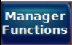->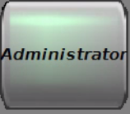-> 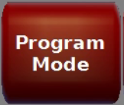-> 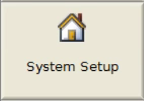
Select Options 1 tab. 1. 24 hour operations should be set to No (may already be no)
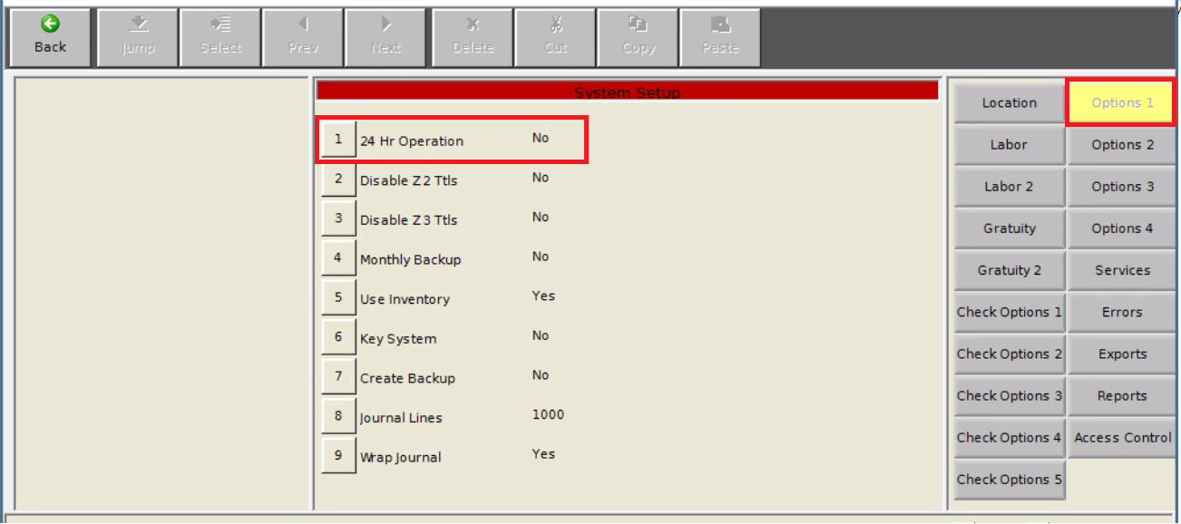
Select the Reports tab and set #4 Z w/Open checks to Yes.
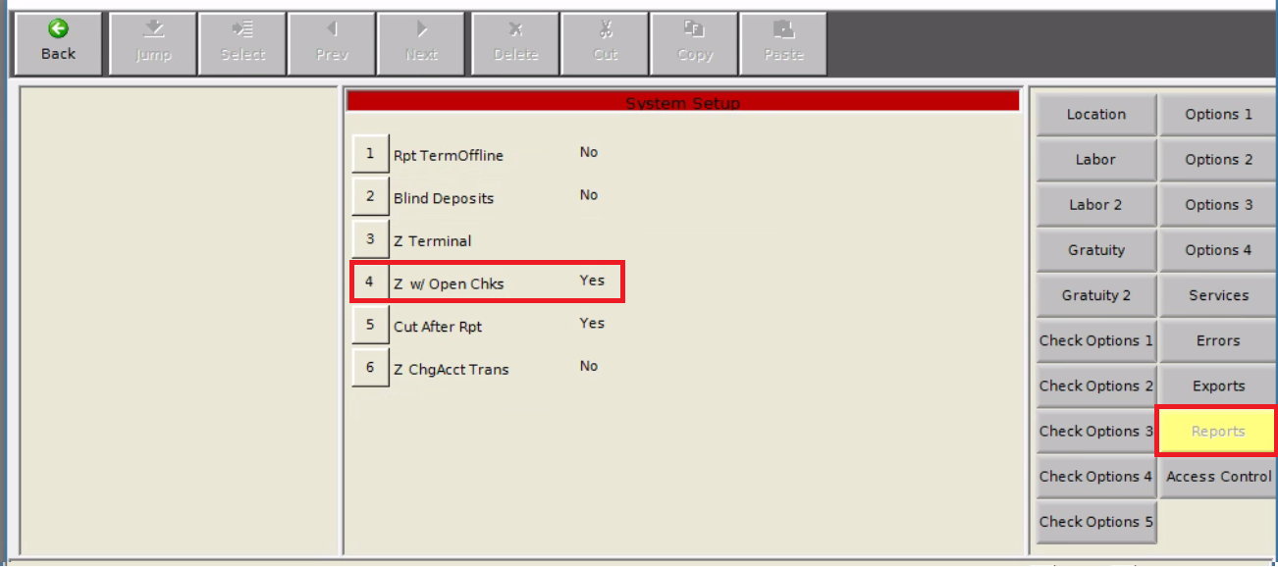
Back out and run the Daily Close.
Once completed, change these two settings back to their original status.

