Star Business Machines

User Manual for

NCC Reflections

Point of Sale

This guide is intended to provide general guidance for the end-user of the system. Please recognize that while Star Business Machines did program your point of sale system, there may be slight differences in the organization of the data within your point of sale system depending on your specifications during set up.

Getting Started – The [Manager Functions] Button
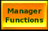

This button is typically located in the upper left hand side of your main menu screen.

This button is used to access all of the different functions that a manager may need to access – programming, reports, timekeeping, and much more.

Initially, you will be greeted with this screen:
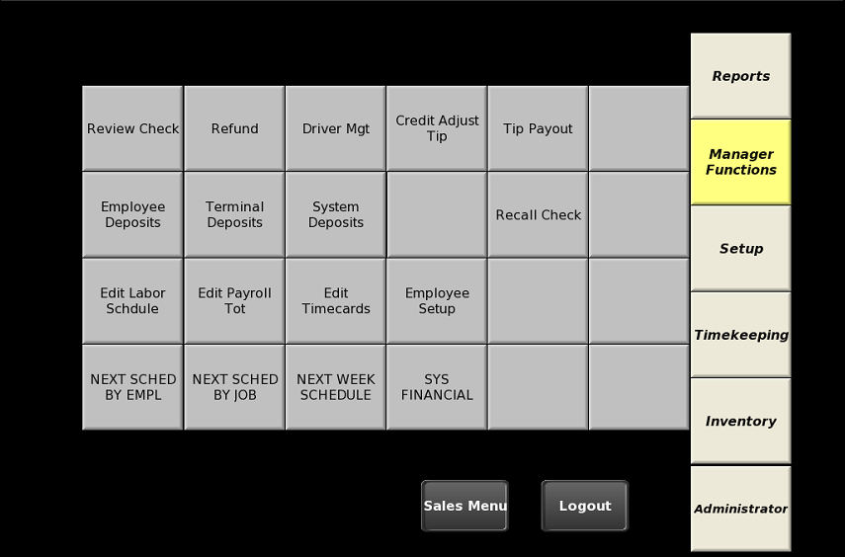

The functions on this screen may vary, but we can change the buttons here to match any special function that you desire- for example we could set up a button to run a z financial report for the end of the day or a button that goes directly to the list of menu items.

To alter a Menu Item:

- Select [Manager Functions]

- Select [Administrator] from the bottom-right portion of the screen
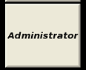

- Select [Program Mode1] from the upper-left portion of the screen.
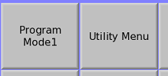

- Select [Menu Item Setup]. This will normally be on the top row.
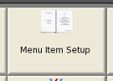

- Select [Select] at the top of the screen.
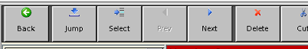

- Select [Search]
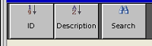

- Enter the name of your item and then hit Enter. Please note there may be more than one item on your menu that match the description. There will be instructions on the following page to help you determine if you’re looking at the correct item. (See image on next page)
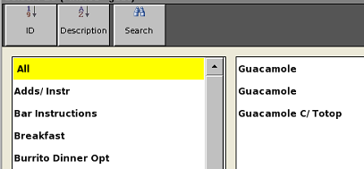

- Select the item you want to edit on the right box on the window, you’ll be directed to the item’s entry page:
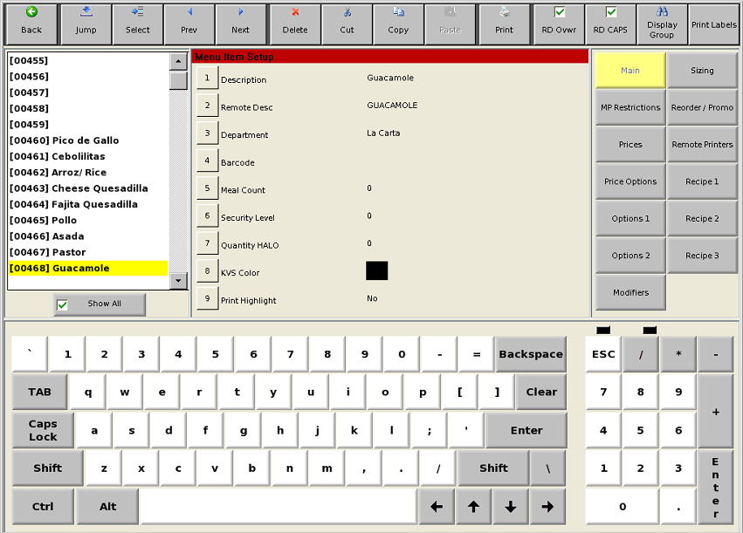

The "Description" determines the name that will show up for your item on the point of sale system (in most cases). The “Remote Desc" is the text that will show up for any external printers associated with the item. Please note that if you use a barcode scanner – the field to enter or edit this barcode is on this page.

Please note that the Department field determines whether this item is part of a specific department, if The menu item is an addon to an existing item, or if it's ala carte on your menu. If you think you’re looking at the wrong item, go back to select and search for the item again. Usually the department should match the screen that the item is on.

- To change the price of the item, select [Prices] on the right side.
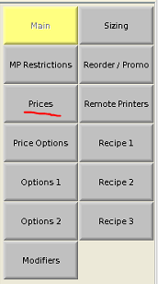

- The item’s price is located under “Normal Price”. If you have any promotional prices, such as happy hour prices, these will be under another number.

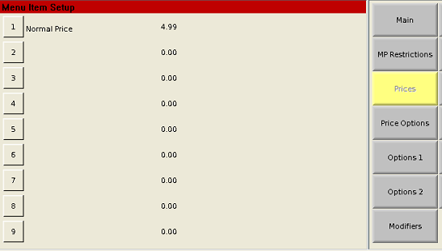

If you are only adjusting prices, skip to #12 on this list.

- Advanced Instructions:

PLEASE READ IF YOU ARE ADDING NEW MENU ITEMS

Modifiers
A modifier allows you to automatically select from a list of options when you submit a menu item. The [Modifiers] button for a menu item will allow you to add a modifier for an item. As an example, if you want to force a menu item to ask for which side the customer has selected after you add that menu item to the bill, then you would select [Modifiers] and then select [1] on that page, then select the department that contains your side options.
Please note if you enter a number by the modifier, then the system will require exactly that many options from that department when this menu item is selected. Enter 0 if you want to allow for multiple selections or zero selections as an option.
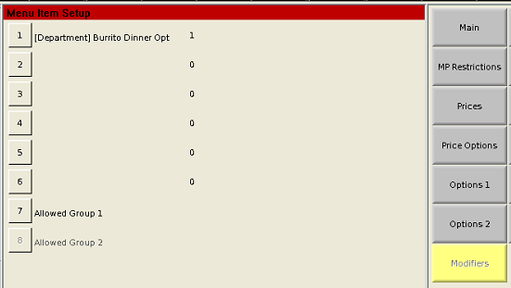

Price Options
Negative Price – Set to No by default. Setting an item as a negative price will actually deduct from the total bill when that item is entered. Usually you would use this for modifier items in order to apply a discount (for instance, if you charge less for ‘No Olives’ then this option may be set to “Yes”.
Open Price – Set to No for most items. If you have this set to Yes, then each time this menu item is selected, it will prompt the user to enter a price for this item.
Add-on Price – This item needs to be set to “Yes” if you have modifiers that cost extra. For instance, if you want to charge extra for adding dressings to a salad, you would mark this as “Yes” so that each dressing would be charged for the price associated with that modifier item.
Rollup Pricing – If this option is switched to “Yes”, then any added modifiers will be included in the total cost on the receipt for that item. If it is set to “No”, then each modifier item will have it’s own price listed on the receipt.

Sizing
To add sizing to an item, you must first set up a ‘size 0’ which will need to start on a multiple of ten (0, 10, 20, 310, 1430, etc). You will need a number of available menu items after the size zero depending on the number of sizes you want – each size will have its own menu item.

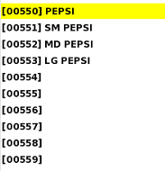
In the Example, [00550] Pepsi is ‘size 0’ for this Menu item. ‘Size 1’ is [00551], size 2 is [00552] and size 3 is [00553]. On the Pepsi [Sizing] screen, this shows that sizes 1, 2, and 3 have been activated.

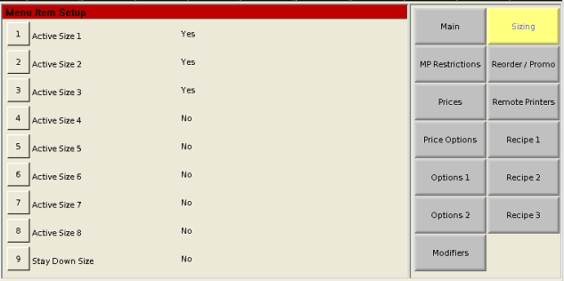

The reason why you only want to activate the sizes you are using, is that if you were to have an entry for another menu item within the range of 00554 to 00559, then it would only be available if the corresponding size option was selected.
If you need a screen set up with sizes for a menu item, please contact Star Business Machines for assistance. We do not recommend you adjust the screens yourself, as it is easy to unintentionally delete a screen or button.

Remote Printers
On this screen, you will see a list of the printers that are set up on your Point of Sale System. Select yes if you would like your menu item to print on that printer. Select the number by the printer’s name to toggle between Yes or No for printing this menu item on that printer. Printers should be set up by Star prior to going live with your system.

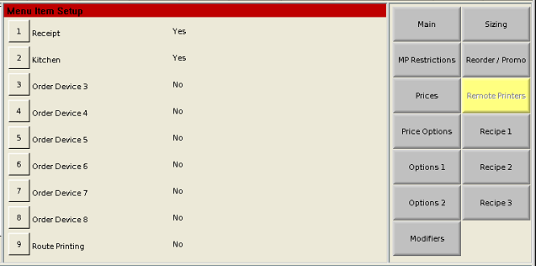

- When you are done adjusting the Menu Items, select [Back] until you are on the Administrator screen and then select [Sales Menu] to get back to your menu or [Logout] to get back to the login screen.

Sample Image
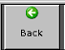

Setting Up Employees
- Select [Manager Functions]

- Select [Administrator] from the bottom-right portion of the screen

- Select [Program Mode1] from the upper-left portion of the screen.

- Select [Employee Setup] in the upper right portion of the screen.
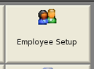
- If you’re adding a new employee select an existing employee who shares the same role, and select [Copy] at the top of the page. Then select a blank number and [Paste].
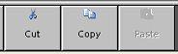
After pasted, update the name of the new employee and set up a login code (by default the login code matches the number for their entry.

- ADVANCED OPTIONS:
Main –
Last Name, First Name – The name of the employee for this entry.
Login Code – The number used by this employee to login to the Point of Sale System.
Password – If set, a numerical password will be required for any over-rides that are allowed by this person. For example - if a user wants to void an item and their job's security level is 70 and void item is set to a security level of 90, then the system would prompt that user for a manager login code and then their password.
Card Number – This is used if you are having employees log in via Magnetic Strip. To enter this number easily, select [5] on this screen and then swipe the card that will be used for login.

Flags –
Hourly – This flag is used to determine if this employee’s hours are being tracked on the system.
Require Clock in – This is used if the employee is required to be clocked in before they can log onto the point of sale terminal. Exemptions to this rule are usually the manager or owner of the business, and any salaried employees who are not tracked hourly.
Clock In Only – Setting this option to Yes will make it so that this employee can only clock into the point of sale system, but cannot log in and see your menu screens.
One-Touch Login – Used if your system is set up for quick login (just the number and no ‘Login’ button).
Training Mode- This is typically only used by trainers. Items processed by employees in this mode do not get applied to your financial reports or totals. Receipts and printed slips on remote printers will be marked as Training Mode. Please note that even though this employee actions does not apply to financial reports, any orders created still need to be tendered in order to run Z reports at the end of the day.
Drawer Port – Do not change this field.

Job Codes – In this section, you will select which job(s) that employee will have access to during login. When this person logs in, they will be asked which job they are accessing. Depending on the job codes that are active, an employee may not have access to certain screens or functions.
If you need to add new job codes, this option is available under [Manager Options] → [Administrator] → [Program Mode1] → Job Code Setup. It is recommended to just copy a similar job code and adjust the security level and description on the new code rather than creating a new one.

Display Groups
If you would like to add a modifier (see modifier section of guide for more details) comprised of items from different departments, display groups are the way to go.

Setting Up Display Groups
- Select [Manager Functions]

2. Select [Administrator] from the bottom-right portion of the screen

3. Select [Program Mode1] from the upper-left portion of the screen.
4. Select [Display Grp Setup] from the bottom-left portion of the screen
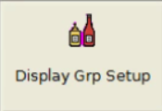
5. To create a display group, find an empty space and enter a name and screen link
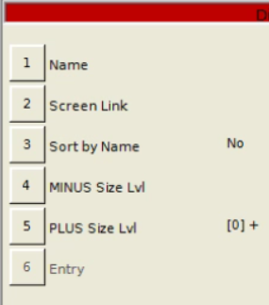
- Add any menu item to the display group by selecting the [6]Entry button and hitting new.
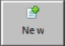

7. Now that your display group has been set up it may be used just like departments as a modifier.
Quick Reference Page:

FOR MENU ADJUSTMENTS
→→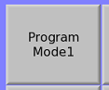→ →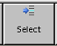→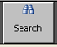

- (above) Search for item you are looking for by item description
- Double check to ensure the item selected has correct department
- Price adjustments are on the right side of the page under [Pricing]

FOR EMPLOYEE SETUP
→→→
→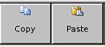
- For new employees copy an existing employee with the same role (or use one of the role templates).
- Adjust name to the new employee and (optional) set their login code.

