

**PinPoint Scan 3 “PC not found” message**

This may occur when a PC is set to dynamic and changes IP addresses, usually in instances where the PC is turned off or used in a different location and then brought back to the network with the shared MFP. First obtain the IP address of the user’s computer.

1. Type CMD in the Windows search bar of your start menu.



1. In the black box, type ipconfig.

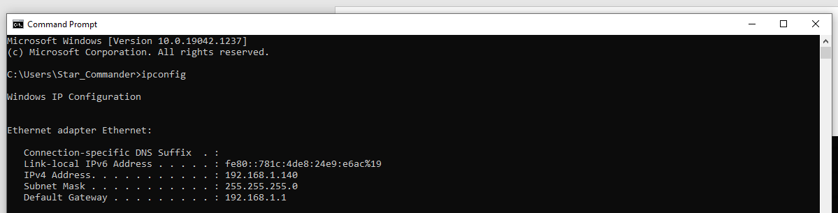



1. At the copier, press enter IP address:

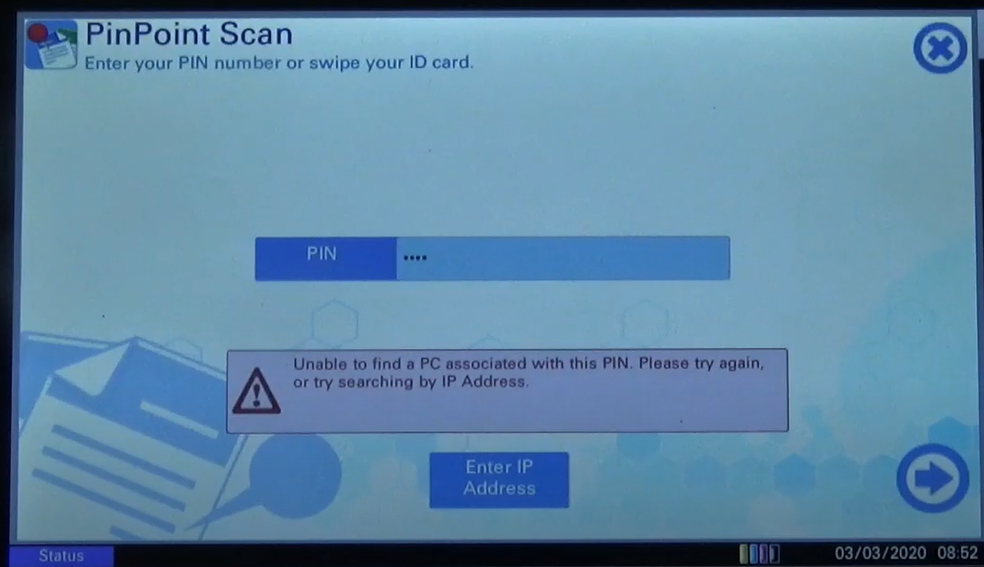

1. Enter the IPv4 from step 2.